

WHAT IS THE CRTC AND WHAT DOES IT DO?
Parliament has given the CRTC the job of regulating and supervising the broadcasting and telecommunications systems in Canada. The CRTC does not intervene in newspapers, magazines, cell phone rates, the quality of service and business practices of cell phone companies, or the quality and content of TV and radio programs.
In broadcasting, the CRTC ensures that all Canadians have access to a wide variety of high-quality Canadian programming. Programming in the Canadian broadcasting system should reflect Canadian creativity and talent, our bilingual nature, our multicultural diversity and the special place of aboriginal peoples in our society.
In telecommunications, the CRTC ensures that Canadians receive reliable telephone and other telecommunications services, at affordable prices.
The CRTC supervises and regulates over 2000 broadcasters, including TV, AM and FM radio and the companies that bring these services to you. It also regulates telecommunications carriers including major telephone companies.
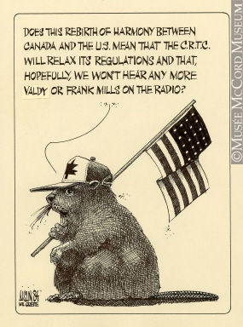
WHAT IS THE DOMINION INSTITUTE AND WHAT DOES IT DO?
Historica Canada, previously known as The Historica-Dominion Institute, is a national charitable organization that was launched in September 2009 through the union of two existing organizations: The Historica Foundation of Canada and The Dominion Institute.
The Historica Foundation of Canada was launched in October 1999 with a mission to help all Canadians come to know the fascinating stories that make our country unique.
The Dominion Institute was formed in 1997 by a group of young professionals, concerned about the erosion of a common memory and civic identity in Canada.
Since the merger in 2009, Historica Canada has grown significantly, launching 5 new programs and expanding existing ones. Among the new programs are; My Parks Pass, which encourages young Canadians to experience Canada’s national parks and historic sites; Sir John A Day, which celebrates the life of Sir John A. Macdonald; and The Citizenship Challenge, a contest based on Canada’s citizenship test. The Memory Project: Stories of the Second World War has now been expanded into The Memory Project Archives, and will include stories of the Korean War. The HDI has also succeeded in finding new ways to bring great history content to classrooms and Canadians, from the publication of We Were Freedom: Stories of the Second World War, a collection of stories from our archive, to our educational guide to Lawrence Hill’s Book of Negroes through to our Memory Project DVD “Witnesses to Our History”.
With much more to come, Historic Canada feels confident in declaring that Canada’s past indeed has a bright future!

