Adolf Hitler (1889 - 1945) |  | Vladimir Lenin (1870 – 1924) |  | Joseph Stalin (1878 – 1953)
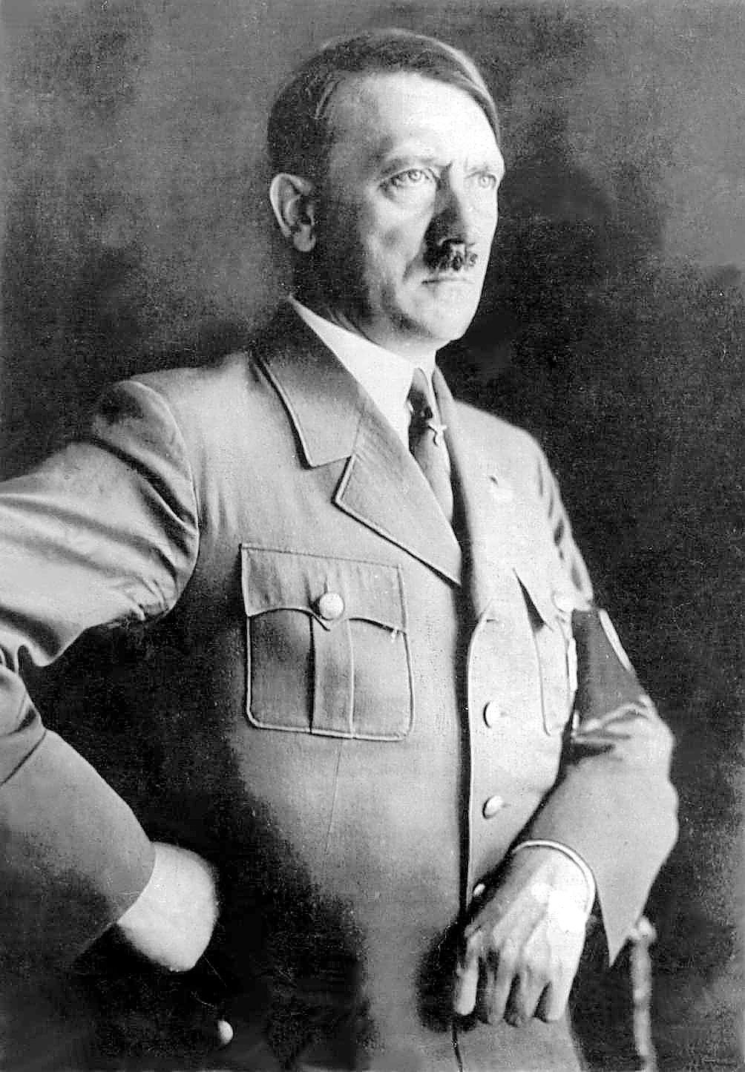 | Most Important Position: | 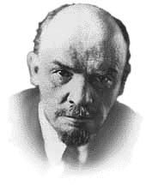 | Most Important Position: | 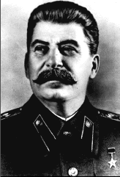 | Most Important Position:
History: |  | History: |  | History:
Ideology: |  | Ideology: |  | Ideology:
Main Ideas: |  | Main Ideas: |  | Main Ideas:

