**USING SOURCES IN WRITTEN RESPONSES**

Every exam that you write will have a Written Response component which will include outside sources such as quotes, cartoons, photographs, etc.  In order to thoroughly answer the question You MUST make use of all the sources within the question.

**Steps for completing written responses**

**View Sources**

Analyze the sources to discover what they are saying about the issue.  Then, write **summary notes** for the main points of each source, and what each source is indicating.

Then provide your own opinion as to whether you agree/disagree with that source.

**Respond to Sources**

Using your **summary notes** as a guide, expand your thoughts about each source into paragraph format.  It is usually best to start each new paragraph by indicating which source your are discussing, then going on to analyze the source.

**Understand Sources**

If you do not understand what message a source is trying to convey, you can either leave that source out and deal effectively with the other sources, or you can indicate that you do not feel the source is conveying a clear message, and explain why.

**Complete the Written Response**

Be sure to address all sources and give your own opinions on the issues.  
Proofread and edit your work before submitting.

**EXAMPLE WRITTEN RESPONSE QUESTION....**

An example of a written response question might be as follows:

***What do the following sources convey about the impact that globalization is having on the world today? In your opinion, which source is most accurate and why?***

Some possible source types are shown below:

**SOURCE ONE**  
Globalization, as defined by rich people like us, is a very nice thing... you are talking about the Internet, you are talking about cell phones, you are talking about computers. This doesn't affect two-thirds of the people of the world.   
                                                                                                 Jimmy Carter - former President of the United States

**SOURCE TWO**

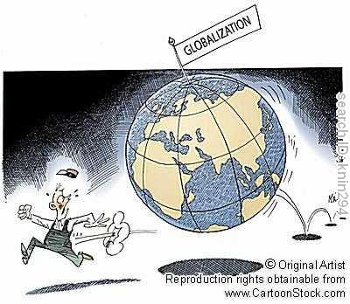

SOURCE THREE

