**Redressing the Wrongs: Responding to Slavery**

***How should contemporary society respond to the legacies of historical globalization?***

**Slavery in the times of imperialism** brought thousands of Africans to the Americas to work on plantations. Slaves had few legal rights, and in many ways they were not treated as human beings. After slavery was made illegal, former slaves and their descendants were uneducated and poverty stricken. Racism in the United States became an issue.

**Source One   
Institutionalized racial discrimination**

In the early 1920s, many white homeowners in the United States feared that the presence of blacks would reduce the value of their properties. The government provided low interest mortgages to white homeowners and military families, allowing them to build homes in better neighbourhoods. These same loans were not available to blacks. At the same time, better roads and even elevated highways to serve the suburbs were built through largely black urban neighbourhoods, further decreasing property values.

Racial discrimination continues. The descendants of former slaves are the black people who now live in the United States, the Caribbean, and parts of South and Central America. Poor social conditions including poverty, lack of education, limited employment opportunities, and crime have been an ongoing legacy of imperialism for many African Americans in the United States. The United States government decided action was needed; a number of government initiatives have bee designed to deal with this issue.

**Creation of Liberia and Sierra Leone**

Two nations were established in Africa as homelands for poor black people and former slaves.

**Liberia** was established by American missionaries as an independent nation, a homeland for slaves who had been freed from their owners. Thousands of former American slaves moved to Liberia. It was unofficially supported by the United States for many years.

**Sierra Leone**, right next to Liberia, was a former Portuguese slave trading centre. It was established as a homeland for poor blacks by Great Britain in the 1700s and was for a time a British protectorate and later a British colony. Both nations were founded with good intentions, but the settlers who arrived from the United States and Britain were former slaves who had originated from all across Africa. Uprooted from their own homes as slaves, they proceeded to displace the indigenous African tribes in their new homeland. Generally speaking, they were wealthier, more educated, and had far greater political power than the local people. Eventually, this led to tribal conflict and brutal civil wars that have just recently ended with the deaths and mutilation of thousands of people, and displacement of millions.

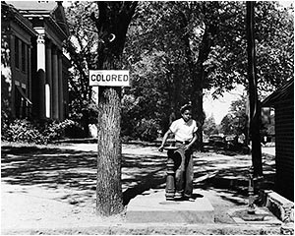

**Segregation of schools**

In many areas of the United States, particularly the southern states, laws encouraged or demanded segregation of blacks and whites. The races were kept separate, with separate schools, hotels, bars, hospitals, toilets, parks, and telephone booths, and separate sections in libraries, cinemas, and restaurants, often with separate ticket windows and counters.

American federal and state laws that were enacted between the time the slaves were freed (1873) and the United States Civil Rights Act of 1964 were known as **Jim Crow Laws** after a popular 19th century song that stereotyped African Americans. The laws discrimated against African-Americans in many ways.   
For enrichment, refer to the following [PBS](http://www.pbs.org/wnet/jimcrow/index.html) site.  
  
**Rent the movie "Blood Diamond" about Sierra Leone.**

**Black students attended different schools** than other students. In some cases, they were bussed from the neighbourhoods where they lived to attend black schools. Often these schools were poorly funded and poorly staffed, providing an inferior education to students. Even when the schools were more or less equal, they were often far away from the students' homes. Perhaps more importantly, they kept white and black people apart so they did not learn tolerance and understanding between the races. A legal battle in the 1950s resulted in enforced integration of white and black students into schools. In communities where it occurred, this movement to de-segregation caused tensions.

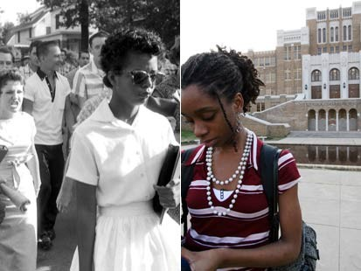

**Source 2  
Affirmative Action**

In 1965, US President Lyndon Johnson established a program called "affirmative action" or "Equal Employment Opportunity". **Affirmative Action** is designed to improve conditions by increasing educational and employment opportunities for groups of people who have been discriminated against. This includes racial groups, women, and other members of the lower class. In the United States, it worked primarily to improve conditions for African-Americans. Under the ruling, any organization with fifty or more employees and revenue over $50 000 from a government contract was required to have a written affirmative action plan that included goals for increasing the numbers of employed women and racial minorities.

President Johnson said,

|  |
| --- |
| *You do not take a person who, for years, has been hobbled by chains and liberate him, bring him up to the starting line in a race and then say, 'You are free to compete with all the others', and still justly believe that you have been completely fair.* |

**Universities actively recruited minority students**. The program gave preferential status to certain minority students, including African-Americans, Native Americans, and Hispanic-Americans. Asian-Americans were not included because they generally have a higher than average enrolment at universities. A minority student with lower grades than a non-minority student received preference in placement in a university program. Scholarships were also made available. The program was very popular at first, but it became controversial because many people believed the African-American students were getting unfair advantages and did not have to work as hard to get into university as other students. Many people considered it a form of "reverse discrimination". However, university enrolments for black students did rise substantially because of affirmative action.

|  |  |  |
| --- | --- | --- |
| **African-American** | **1960** | **1995** |
| College graduates | 5.4% | 15.4% |
| Law School enrolments | less than 1% | 7.5% |
| Medical School enrolments | 2.2% | 8.1% |

**Affirmative Action today:**

In recent years, a very few states have passed legislation to prohibit preferential hiring or college enrolment on the basis of race or gender.

**Focus on the Issue Question:**

Logic tells us we cannot change the past, but we can act to create a better future. The United States government took action to improve the situation for African-American people by providing them with preferential treatment.

**To what extent is preferential treatment is a good solution to the problems associated with historical racial discrimination?**