**Background to the Crisis in Darfur**

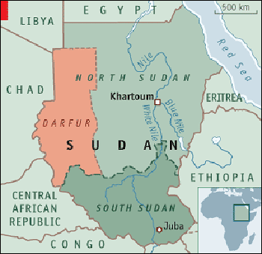

**Sudan's Government**

The **Republic of Sudan,** one of the largest and most diverse nations in Africa, was formed in 1956 when it was granted independence by Britain, which at the time also controlled Egypt to the North.

**Ethnic and religious differences have plagued Sudan**for almost its entire existence. Except for a period of peace from 1972 to 1983, the country has been embroiled in civil war. It is a place where many years of civil conflict over land and resources has led to the marginalization of its citizens and chronic poverty.

Sudan is split between the Muslim, largely Arab North and the more religiously and ethnically diverse South.

For most of its history, Arabs in the North have controlled Sudan and sought to unify the country along the lines of Arabism and Islam. However, ethnic and Christian groups to the South have resisted, demanding self-determination and freedom from Islamic, or Sharia, law.

The most recent conflict has been especially severe in the **Darfur**region of Sudan and dates back to early 2003 when black Africans from Darfur rebelled against the country's Arab Muslim leadership demanding improved infrastructure in the region, proceeds from oil wealth and a power-sharing government. The Sudanese government retaliated by sending in government forces to quell the rebellion. The government also reportedly organized and supplied the Janjaweed militia to combat the rebels.

**The Janjaweed**

Much of the population of the Darfur region of Sudan belongs to one of the three tribes - Fur, Massalit, and Zaghawa. Rape, mass murders, kidnapping and disease are prevalent in this area of Sudan. Armed militia known as the Janjaweed have looted and burned many of the villages in Darfur. The name Janjaweed is a combination of Arabic words meaning outlaws, gun and horse -- appropriate associations, as observers often tell stories of Janjaweed militiamen riding horses and brandishing heavy weaponry like AK-47s and G-3 rifles.

The Janjaweed have primarily targeted the Fur, Tunjur, Masalit and Zaghawa ethnic groups, presumed to be sympathetic to rebels opposing the government. The attacks against the non-Arab Muslims by the Janjaweed have been "grossly disproportionate to the military threat of the rebellion," wrote Alex de Waal in a 2004 essay that appeared in the London Review of Books.

A religious agenda does not impel the Janjaweed, de Waal said. Its motivation is land, but blatant racism and a political ideology known as "Arab supremacism" also fuel the Janjaweed's agenda.

The Janjaweed are both "cleaning" the land of non-Arabs and viciously combating the rebellion while receiving impunity from the government in Khartoum, de Waal said.