***Historical Globalization Position Paper Source***

***NOTE: you can choose to use ONE or MORE of the following topics as a source.***

**Rwandan Genocide (Source One)**

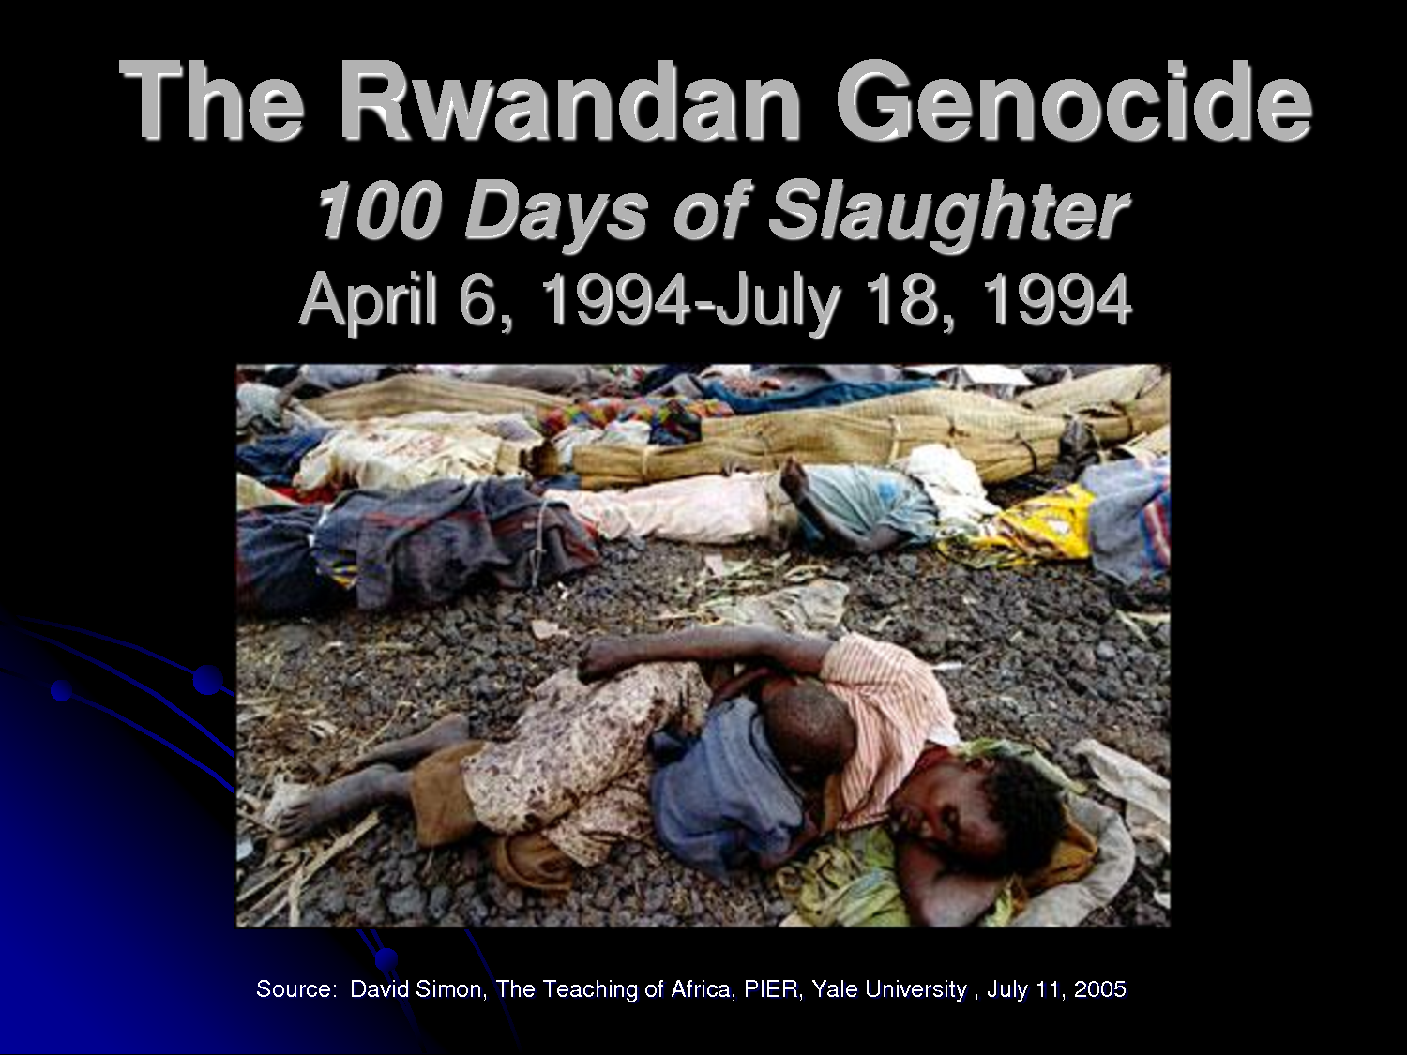

* Before the 'scramble for Africa', what is now Rwanda was occupied by 2 Indigenous groups, the Hutus (85%) and the Tutsis (15%)
* German colonial officials reinforced traditional distinction by appointing the Tutsis to key position within the colony
* Tutsis were 'more like Europeans' than the Hutus - and this gave them the right to a higher status
* After WW1, treaties transferred this region to Belgian control, who forced the two groups to carry card of identification
* Belgians left Rwanda in 1962 and conflict broke out between the Hutus and the Tutsis over who would hold political power
* The Hutus formed the government and many Tutsis fled
* 1980s economic problems made the Hutus government unpopular, Tutsis patriots invaded from Uganda refugee camps, and the Rwandan government began a campaign against Tutsis, and sympathetic Hutus
* April 6, 1994, Rwandan president Juvenal Habyarimana's plane was shot down and Hutus immediately blamed Tutsis
* Hutus propaganda encouraged revenge, and the militia favoured hacking their victims to death with machetes
* By July 19, 1994, an estimated 800 000 - 1 000 000 Tutsis and moderate Hutus had been killed
* United Nations peacekeepers - originally under the command of Canadian lieutenant general **Romeo Dallaire** was stationed in Rwanda since
* Dallaire had warned the United Nations of rising tensions between the Hutus and the Tutsis
* UN ignored Dallaire, insisting that their role was to prevent conflict **between** countries and to stay out of conflicts **within** countries
* UN ordered Dallaire's peacekeepers not to interfere and not to fire their weapons except in self-defence
* They were also ordered to not protect civilians so that it would not look like the UN was 'picking sides'
* Peacekeepers only focus was to evacuate foreign nationals

**South African Apartheid (Source Two)**

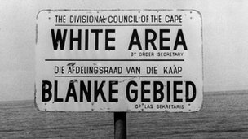

* In 1692, South Africa was colonized by the Dutch, Portuguese, French, and British
* In 1926, South Africa became an independent dominion within the British Empire
* Blacks outnumbered Whites by a ratio of 10 to 1, because of this, the government passed laws to ensure that whites held onto political and economic control, barring blacks from voting
* After WW2, the South African government introduced **apartheid,** laws that segregated the population
* South Africans were classified as white, Asian, coloured (mixed ancestry), or black and forced to live in separate areas, go to separate schools, and work racially designated jobs
* Many groups tried to end the apartheid, but the government banned protests and locked up leaders, including **Nelson Mandela**
* June 16, 1976, 15 000 - 20 000 black high school students in Soweto demonstrated to demand better education
* Apartheid law stated "Natives must be taught from an early age that equality with Europeans is not for them"
* In 1986, under extreme pressures from the international community, South Africa started dismantling apartheid
* In 1994, South Africa held their first free election, and Nelson Mandela was elected president
* Mandela established the Truth and Reconciliation Commission to help South Africans confront their country's violent past

**Canadian Internment Camps (Source Three)**

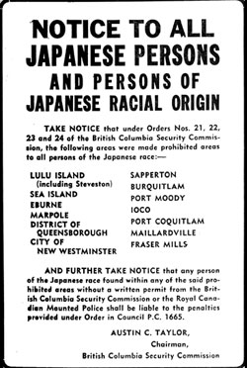

* By 1914, more than 1 million people from Germany and Austria-Hungary had immigrated to Canada, but they were now considered Canada's enemies
* Canadian government feared these immigrants were spies
* They were labelled enemy aliens and ordered to report regularly to the police and their rights were restricted
* More than 8500 German and Ukrainian Canadians were interned, and held in prison-like conditions, and some were forced to build roads in Banff and Jasper National Parks
* The federal government has offered $2.5 million for memorials and education programs about the internment, but Parliament has not apologized
* In 1941, Japanese forces bombed Pearl Harbour and attacked British and Canadian troops in Hong Kong
* Japanese Canadians became a target of suspicion
* All Japanese Canadians were moved away from the Pacific coast to internment camps, allowed to take only what they could carry, while all other possessions were confiscated
* After the war, Japanese Canadians sought compensation, and in 1988 a settlement was reached, with each internee receiving $21,000
* The government also apologized and established the Canadian Race Relations Foundation to help eliminate racism

**The Indian Act (Source Four)**

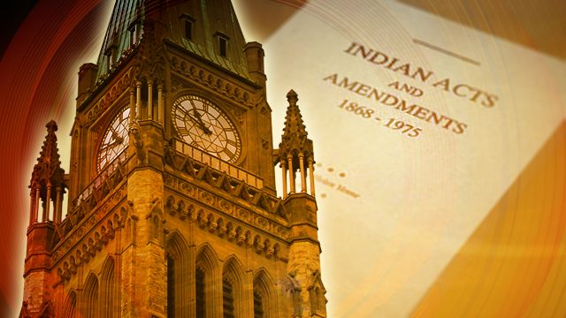

* First passed in 1876 as a government tool to encourage assimilation. Remains in place today.
* Defined who was - and was not - a status Indian.  A **Status Indian** is someone who is registered according to the provisions of the act and is therefore eligible to receive specific benefits.
* Banned some traditional practices, such as the potlatch ceremony of Pacific Coast First Nations and the Sun Dance of Plains First Nations.
* This Act is a continuing and controversial legacy of imperialism in Canada
* First Nations argue that the Act ensures that First Nations peoples do not receive equal treatment, limits First Nations' rights to self-government and self-determination, and assumes that federal government officials are the best judges of the needs of First Nations peoples
* The federal government has acknowledged the fact that changes need to made with regards to the Indian Act

**The Depopulation of First Peoples (Source Five)**

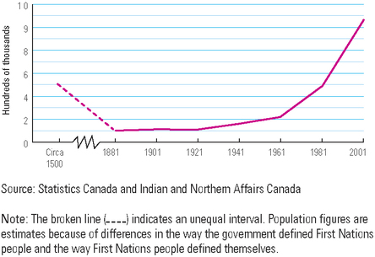

|  |
| --- |
| * First Nations were pushed into unproductive lands, as they were driven from their familiar territories, their traditional relationships with the land, and its resources were harmed * these migrations sometimes created tension and conflict among First Peoples and upset the delicate balance between First Nations and the land * European diseases devastated First Nations * 1870 - a Smallpox outbreak killed thousands of Cree and Blackfoot people |

**Residential Schools (Source Six)**

* Schools where First Nations children were gathered to live, work, and study - were another important tool in the government's assimilation policy.
* set up because the Indian Act made the federal government responsible for educating First Nations children.
* Starting in the 1880s, school-age children were taken from their families, sometimes by force, and placed in these schools.
* First Nations families were given no choice, no voice, and no options in the matter.  Every August, children were taken from their family and shipped to school, where siblings were separated by age and sex.
* Responsibility for running the schools was shared between the government and Christian churches.

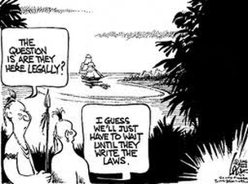

**(SOURCE SEVEN)**